This email looks better with images enabled.

To view this email online, [link]


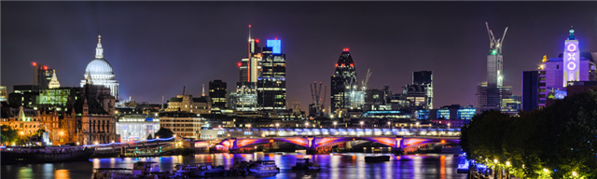

INVESTMENTS

MORTGAGES

PENSIONS

PROTECTION



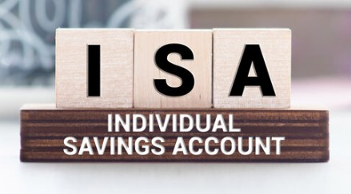
I
HELLO RODNEY, OH HELLO CHARLES
Haven’t seen you since we came down from Oxford together, did you get into the City?

Yes, I’m designing Investment ISAs for our fund managers. Terribly good these ISAs, incredibly flexible and no tax. Jewel in the Crown of Investments.

Sounds good , lets drop down to the RAF Club for a tipple and you can tell me all about it.

Cheers! Well these ISAs, a totally tax free investment, no tax on the ISA Fund, and no income tax or capital gains tax when you take your money out.

Yes, but I heard you can only hold a certain amount and must be for a certain time period.

No sir! You can invest up to £20,000 per tax year, either as lump sums or monthly savings, but you can build it up to any size of portfolio you like.

Portfolio of ISAs you say, sounds very professional. I’m in the Buy to Let business and that’s going to hell on a hand cart. We pay higher interest rates which are rising. property values are falling, higher stamp duty going in and now higher capital gains tax when selling. It’s difficult to make money on Buy to Lets these days. Tell me more about these ISA thingies.

Well, anyone can have an ISA, Felicity my wife has invested £20k each year, and doing very nicely thank you, we’ve started Junior ISAs (JISA) for our kids, and Grandad adds to it. When the kids are 18, its theirs, do what they like with it. Go on world trips, pay off Uni fees. Difficult if they want a Kawasaki 650, but we want them so save for their future house deposits.

It all sounds very attractive m’boy but I bet that crew over at Westminster restrict you getting your money back, and surely there’s a lock-in period, what?

Nope! Easy access at any time and all tax free. Money in when you like, take money out when you like, and as you like. Take out lump sums, or as monthly income, all absolutely tax free. Save up year by year to a big ISA portfolio and then take a tax free income in retirement. Its magic. And talk about flexibility, you take money out and put it back again in the same tax year without loosing the tax free status.

Trouble is Roders, you’ve got to use money you’ve already paid tax on. You don’t get any tax relief on your savings like a pension.

Not so Charlie boy. There’s a Lifetime ISA (LISA) where the Treasury add another 25% on top of your savings up to age 50, and that’s perfect for adding to your retirement fund or as a deposit for a First Time Buyer of property.

OK I can see some merits in this ISA thing, total flexibility savings going in with tax free growth and tax free funds coming out, but I wager they hit you for Inheritance Tax when you kick the bucket.

ISAs do form part of your personal estate, but your wife or partner can inherit your ISA without loosing the tax free status. No tax to pay and no IHT. The clever thing to do is build a good size ISA portfolio along-side with your pension plan. When you retire, drawdown tax free income from your ISA portfolio and then you can leave your pension plan to your wife and kids, free of Inheritance Taxes. As the meerkat says Simples! Another drink?

No thanks. Must get off now and buy myself and Josephine an Investment ISA each. We only have until 5th April to get it sorted.

Ray

ISA ENQUIRY

State pension rise to 68 will not be brought forward yet
click the button below to read the article

BBC Business News

