Investment Traps Ahead!

To view this email online, [link].


"Financial advice given simply by Professionals"


  
  
  
  
Investing Traps to Avoid

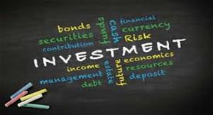
I
If you aren't thinking about owning a stock for ten years, don't even think about owning it for ten minutes.
So what should investors do?
Read our two page article on this important approach to investing.
click here to read the full article

Unclaimed pension tax relief


Here we look at what you need to know about these tax advantages and how to reclaim the money you could be owed, as well as what rules and limits to look out for.

click here to read the full article

5 Ways to get more secure income in retirement


How could you increase your pension income over and above the State Pension, annuities, and defined benefit pensions?
click here to read the full article
Stay safe, it's still out there!
Ray Jenkins

