THE SEESAW EFFECT
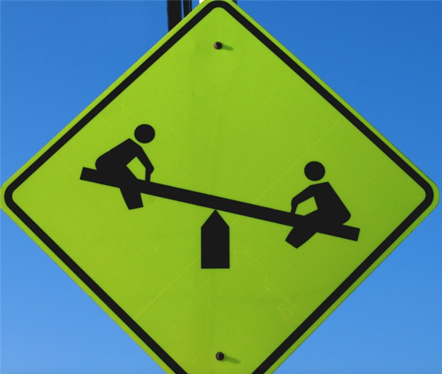

Those investors who keep a close eye on the ever changing value of their investments, may be wondering what’s going on with the international stock markets. Some up some down, like a seesaw.
Some may have noticed that although the overall value of their total investments or pensions may have remained steady or even gone up a little, their American holdings may have dipped somewhat over the last couple of months.

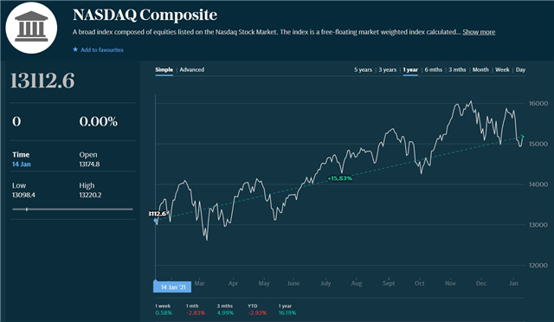

At this time all the international markets are going through a change or correction and this is due to many factors. Here is the main cause. The pandemic caused lockdowns, stay at home, watch TV, films, shop on line, work from home, meetings by internet. This increased the growth of companies such as Netflix, Amazon, Microsoft, Google, all types of Tech shares of mainly US companies listed on the Nasdaq Index (see graph). American Investment Funds which have been mainly invested in the Nasdaq Index increased in performance and hence the value of our investments and pensions went up. Conversely, the value of shares such as airlines, aircraft and car manufacturers, and generally companies that actually make things went down, because they could not sell their products due to the pandemic.
Now that the pandemic is coming to an end (hopefully) the tech shares are going down in value and as a consequence the performance of those American Funds invested in tech shares has been falling over the past 3 to 6 months.

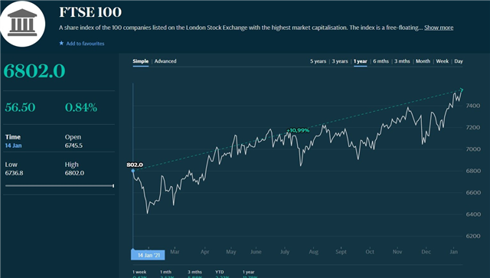

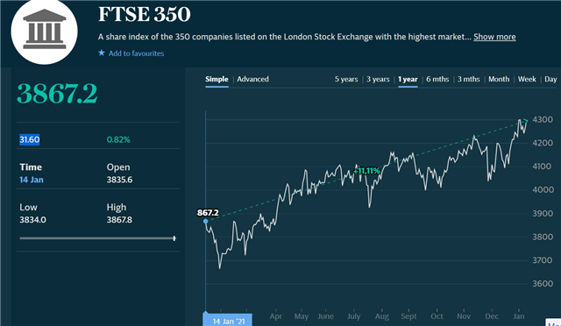
However, its not all bad news. Look at what has been happening to the FT100 over the same period. As you can see from the (FT100 and FT350 Indices), they have been going up quite nicely over the same period. The reason is that the UK stock market, without many tech shares within the top 100 companies, suffered the opposite effect during the pandemic, but now that the markets can see an end is in sight and the world is buying into UK stocks. As our investors pensions and investments are diversified over all the international markets, the recent fall in American Funds is being offset by the gains in the UK Funds.
Take care, keep safe. It’s still out there.
Ray

