This email looks better with images enabled.

To view this email online, [link]




INVESTMENTS

MORTGAGES

PENSIONS

PROTECTION

The Mortgage Quandary, Fix or Track?

Anyone looking to buy a property at this time, either as a First Time Buyer or moving home is facing a terrible quandary.

Here’s why. Property prices have fallen over the last 6 months and predicted to fall a further 10% to 20% in value over the remainder of this year. There is even one prediction of a fall of 30%.

The other factor is that mortgage interest rates hit their highest level in October last year and since then mortgage rates have been falling and predicted to fall further over the remainder of this year.

Buying a property at this time does not appear to be a good prospect when the value is predicted to fall quite seriously in the future and the interest rate you choose at this time could be considerably cheaper in the coming months.

There is an even bigger dilemma facing people whose fixed rates packages are coming to an end. There are 1.4 Million households currently holding fixed rates mortgage packages which come to an end during 2023 and around 57% of them are under 2% interest. With the current fixed rates between 4% and 5% depending on the term, it is going to be a big financial shock renewing your mortgage package at double the interest rate of the current one.

So what is the best for the future? Get another 2 year fixed rate at 5.14% in case rates go up further or go for a 2 year discount at 4.09% or tracker at 4.69% hoping that rates will go down or stay on the current lenders standard variable at 5.6% and change mortgages later?

Very difficult decisions for so many people particularly as there are so many variables to consider.

Time to talk to an experienced mortgage adviser who has access to the whole mortgage market and can help you with the decision. Give us a call, we are here to help.

Take care in whatever you do.

Ray



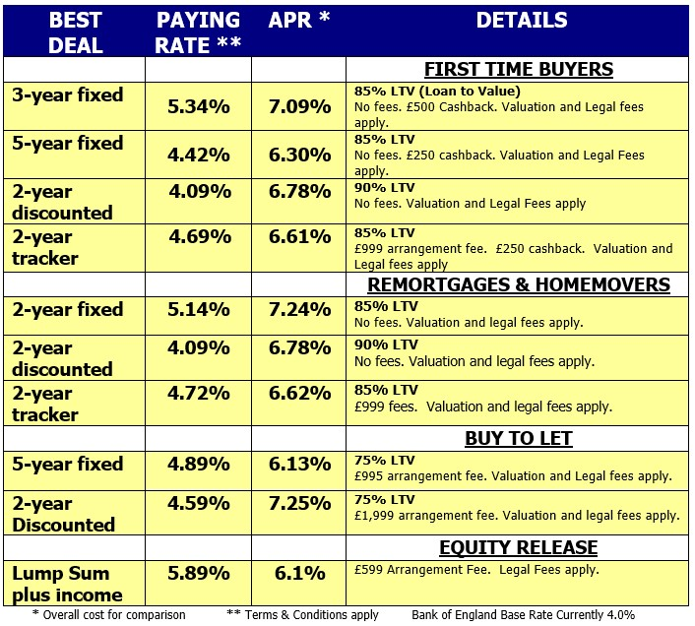



Budget 2023: What could be in it and when will it happen?

click the button below to read the article

BBC Business News

