So which room is Oliver's?

To view this email online, [link].


"Financial advice given simply by Professionals"
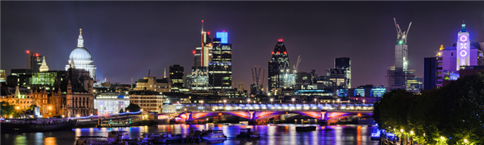

  
  
  
  
SO WHICH ROOM IS OLIVER’S?
If you are thinking of moving house, building an extension for a new kitchen or buying your first property, then it would be best to do it sooner rather than later.
The financial press is full of talk at present about inflation raising its head again and speculating on the effect on world markets. To you and me, it’s rising prices, and the effect these have on our lives. But it’s already started. It has just been announced today that the inflation rate in the UK during April was double that of March. Rising from 0.7% to 1.4%. This means that the extension you are planning or the new kitchen you have in mind will be going up in price.
The more worrying aspect of rising inflation, which is starting to affect the markets, is that central bankers such as the Bank of England, European Bank and the US Treasury may wish to raise interest rates to keep inflation under control.
Rising interest rates quickly means rising mortgage rates and we are already starting to see these increases slowly coming through in the new rates.
So, if you are spending time thinking where Oliver is going to sleep or where to put the microwave, I suggest you quickly make up your mind and start arranging your mortgage requirements.
Here are the best mortgage rates on the market today and we would be happy to arrange the most suitable package for your requirements. Give us a call, we are here to help.
ANGLO INTERNATIONAL GROUP LTD
LATEST MORTGAGE RATES
0800 193 1066

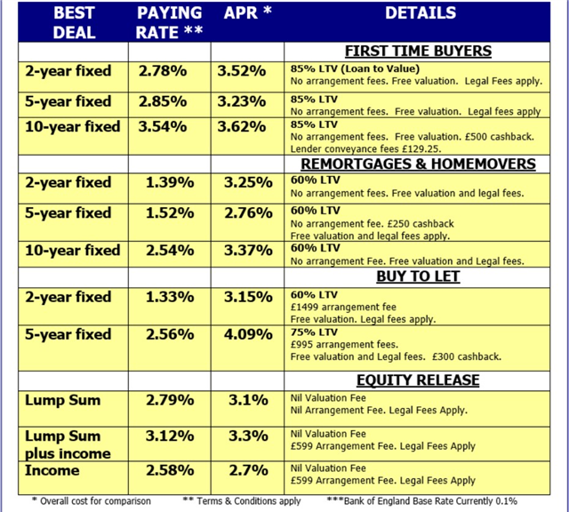

The Investment & Mortgage Centre
info@angloifa.com www.angloifa.com 01483 300777
Written quotations available on request.
All mortgage offers subject to status.
There may be a fee for mortgage advice, typically up to 0.5% of amount borrowed, depending on your circumstances.
All products subject to change without notice. Rates updated 17th May 2021
YOUR HOME MAY BE REPOSSESSED IF YOU DO NOT KEEP UP REPAYMENTS ON YOUR MORTGAGE
Anglo International Group Ltd, 170 Epsom Road Guildford Surrey GU1 2RP
Telephone 01483 300777
Authorised & regulated by the Financial Conduct Authority – FCA 307774

  Click on the Image to make an enquiry -
  

Click on the Money Matters logo to read our Magazine



Click on button below to contact us for independent investment advice

  email: info@angloifa.com
  web: www.angloifa.com

* The value of investments and income from them may go down. You may not get back the original amount invested and the levels, basis and reliefs of taxation are subject to change. Anglo International Group Ltd is an independent financial adviser authorised and regulated by the Financial Conduct Authority no. 307774.

This message was sent to [emailaddress].
Follow this link to [unsubscribe].

