What's Going On?

To view this email online, [link].


"Financial advice given simply by Professionals"


  
  
  
  
What's Going On?
There are a number of factors affecting investment values at this time and most have been strongly influenced by the pandemic. The first one is the gradual move from Growth Stock to Value Stock. The pandemic caused the world to lock down. People were kept at home, either furloughed and looking for something to do, or working from home. This inevitably resulted in the increased the use of computers, mobile phones, Zoom meetings and a lot of watching of televisions. This increased the use of such companies as Netflix, Google, Facebook, etc etc. With the shops closed there was a huge increase in on-line purchasing and the use of home delivery companies such as Amazon and other internet companies. This has obviously increased the value of these growth stock considerably during the last 12 months, and that increased the price of such funds as Baillie Gifford America, Managed, European, which were loaded with the above mentioned companies.
However, now along came the vaccines and the markets looked at the future and saw that those companies would not be needed so much in future as we got back to a “New Normal”. Time to start coming out of growth stock companies and start investing in value stocks such as hotels, airlines, aircraft, engines etc etc. The old normal. This switch over takes from investing in Growth companies to Value companies takes time and that is what has been happening over the last 6 months. Investment funds have been reducing their holdings in Growth technical companies and switching their investments to Value companies. The period during the switch-over can sometimes be turbulent, but the direction of travel is right and things will soon settle down.

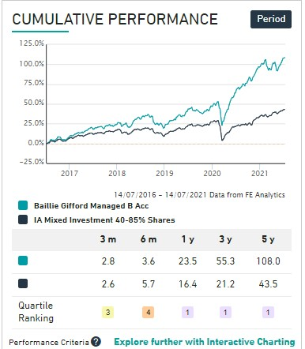
The situation is illustrated by the performance of the Baillie Gifford Managed Fund.

The other factor is the fear within the markets of inflation and its effect on the world economy . At present it is just the fear of inflation. Biden is giving away up to 6 Trillion dollars to the American public and industry to get the American people spending again and to restart the US economy. Because peoples of the world have stayed at home, many have generally saved money, (£71 billion in personal savings in the UK alone), which they can now start to spend. It is feared by the markets that this wall of money will create a huge rise in inflation. It has already reached 2.5% in the UK. This in turn, could force central banks such as the Bank of England, European Central Bank and the US Fed. to increase interest rates to curb the rise in inflation. This will increase mortgage rates, credit rates would go up, and this could bring on a slowdown in the growth. The markets are reflecting this in the values of company stocks, which has been affecting the markets over the last 6 months and resulting in the most popular investment funds, in which you are invested to move either sideways or down over the last 6 months.
Thankfully, the central banks such as the BOE and US Fed and ECB are not bighting to the fear. The view up to now is that the risk of inflation is only going to be temporary, as the turnaround in the world economy will be quite quick. Besides, it is considered that the influences on the markets was caused by a medical problem, which is being solved by vaccines and the problem is not structural.
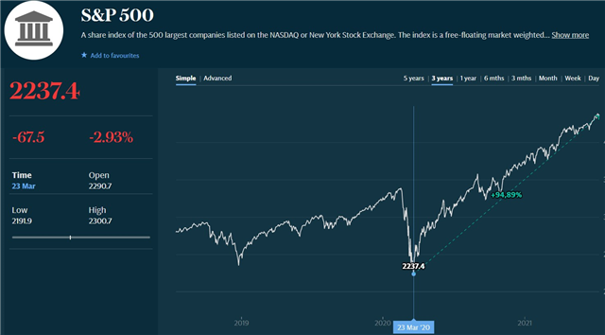

Notwithstanding the markets fear of inflation, the performance of the American Stock Market Index S&P500 shows no sign of slowing down in growth.
Stay Safe, It's still out there!
Ray Jenkins

