This email looks best with images enabled.

To view this email online, [link].


"Financial advice given simply by Professionals"


  
  
  
  

Who do they think they are? King Canute!

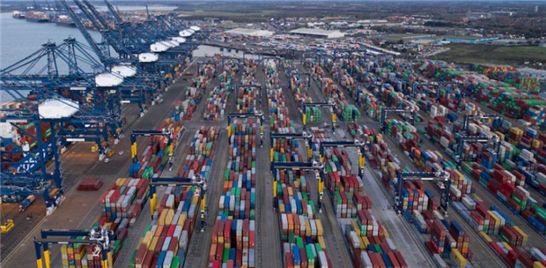

All the contenders to be the next British Prime Minister, have given their views on the rising cost of living and how they will combat inflation.
But rising prices and the inflation which is causing them is not going to solved or combatted by one person or one political party or even one country come to that.
At this particular time, inflation is being caused by some of the very basics. The price of oil and gas which affects practically every thing that we do these days, price of petrol for transport, price of flying
price of manufacturing, plastics, construction, even down the price of our foods. When the worldwide price of oil goes up, prices everywhere and for everything goes up. Of course, if the price of oil goes down then we would expect the prices of everything else to go down.

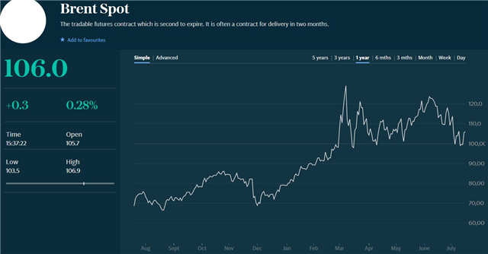
The rising prices of everything today and Inflation today has been produced by the previous price of oil going from a steady $70 a barrel to $129 a barrel just at the time of the pandemic. That is a price increase of nearly double. So let’s take a look at the price of oil over the last year. As you can see from the graph above the price of oil is currently hovering around $105 a barrel. Now that is a pretty substantial drop over the past 6 months. This gives us some hope that the inflation rate of everything else should soon start to come down.

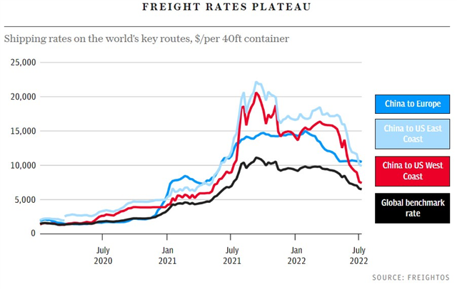
The other major factor which is producing worldwide inflation is what is know as the “carry trade”. That is the cost of shipping goods from one country to another. Two years ago the actual cost of shipping a standard 40ft container (the ones you see in the picture above) was just over $1200 to just simply ship the container from China to the USA or Europe.
During the last 6 months that price had increased to $22,000 to ship to the USA and around $15,000 to Europe. This means that importers in both the USA and Europe have had to increase their prices to take account of their increased shipping costs, thereby increasing the price of goods that we pay for the items inside the container.
Take a good look at the graph above and see how cost of shipping these containers is slowly coming down. Let us hope that this fall in shipping costs continue and that this will soon start to bring inflation down and combat the rising price of living.
There are a number of basics which are slowly improving and I feel confident that we will see a slow levelling off of inflation and even a fall in some prices
Stay safe and keep cool.
Ray

For independent investment advice please contact us either by clicking on the enquiry button below or call us on our
Freefone number 0800 193 1066

.
  
  Click on Investments button to enquire about your investment options.

BBC News
Check your postcode. Is your area vulnerable to extreme heat?
MoneyMatters
Click below to read our magazine


