This email looks better with images enabled.

To view this email online, [link]




INVESTMENTS

MORTGAGES

PENSIONS

PROTECTION

Look Out - for Cheaper Petrol

This week, we have three more hopefully helpful articles for you to read. Firstly, an update on our recent article on the falling prices of oil. As of today, the price of a barrel of oil is down to $93 from the previous high of $105.
If you have any queries on any of the articles, please contact us in the usual ways.
Best regards
Ray
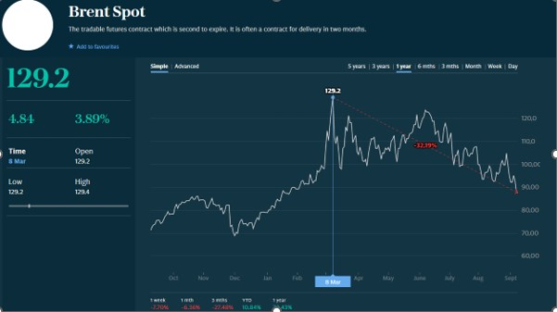

How Much Tax is charged on my pension?
Our pensions are very important to us and we all work hard to build up our pension pots over our working years. It is critical to understand how tax and pensions work ......
click on the title to read the full article





Your Investment Service
- Have your objectives for investing changed?
- Has your risk level changed?
- Have tax rules or allowances changed?
click on the title to read the full article



How to plan for the worst case scenario
Regardless of how much money we have, we all have some idea of personal financial planning in case the worst happens. We take a look at some of the most important things to consider.
click on the title to read the full article

This message was sent to [emailaddress] using NewZapp. Follow this link to [unsubscribe].

