Whoopee! for the Triple Lock System
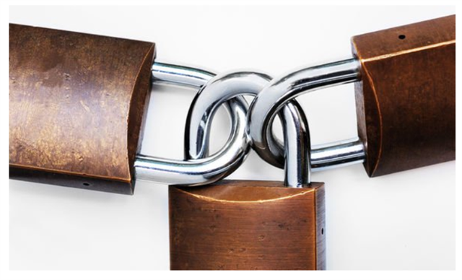

The State Pension is rising by 2.5% in April 2021, resulting in an extra of up to £228.80 a year.
State pensions are increased each year by what is known as the triple lock system by either, in line with earnings, the consumer price index (CPI) or 2.5% whichever is highest. As inflation in September was 0.5% and earnings have remained low throughout 2020, the triple lock system means that those receiving State Pension will, therefore, receive a 2.5% increase in April.
This means the increase in State Pensions is a real net increase of 2% in income and not eroded by inflation as in previous years.
As a result, from April, those on the new full state pension will get an extra £4.40 a week, increasing the weekly pension to £179.60, which results in an extra £228.80 over the 12 month period. Those on the old full State Pension, will get an extra £3.40 a week, increasing the weekly pension to £137.65, which results in an extra £176.80 over the year.
  
  Why is Rebalancing So Important?
  Many people ask the question, What is Rebalancing and How often should I rebalance my investment portfolio?
  Read More
  
  The Three Accounts Rule
  Use it to help you reach your financial goals
  Read More


Click on the Money Matters logo to read our Magazine

Click on button below to contact us for independent investment advice

  email: info@angloifa.com
  web: www.angloifa.com

* The value of investments and income from them may go down. You may not get back the original amount invested and the levels, basis and reliefs of taxation are subject to change. Anglo International Group Ltd is an independent financial adviser authorised and regulated by the Financial Conduct Authority no. 307774.

This message was sent to [emailaddress].
Follow this link to [unsubscribe].

