This email looks better with images enabled.

To view this email online, [link]


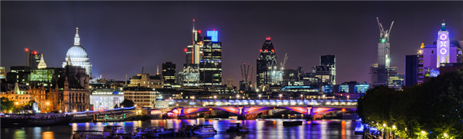

INVESTMENTS

MORTGAGES

PENSIONS

PROTECTION

A couple of interesting articles selected from our Money Matters Magazine for you this week. If you would like to read the full magazine, click on the title below:
Our Money Matters Magazine
Do contact us if you would like any advice on the topics.
Regards
Ray

How to Fund the Lifestyle you want
- There is a feeling of anxiousness with many people approaching retirement due to the effects of the cost of living crisis.
Click on the image to read the full article



Investing for children - the gift that keeps on giving?
- With Christmas approaching, wouldn't it be nice to give a gift that goes well beyond the festive season?
Click on the image to read the full article



US Inflation Rate Slows as Fuel Costs Fall
click the button below to read the article

BBC Business News

CONTACT US

CLICK ON THE BUTTON ABOVE TO CONTACT US FOR INDEPENDENT FINANCIAL ADVICE

www.angloifa.com

Email us here

The value of investments and income from them may go down. You may not get back the original amount invested and the levels, basis and reliefs of taxation are subject to change. Anglo International Group Ltd is an independent financial advisor authorised and regulated by the Financial Conduct Authority no. 307774

