Don't put all your eggs in one basket

To view this email online, [link].

"Financial advice given simply by Professionals"

Don’t put all your eggs in one basket
You would have thought that the “ye olde sayings of yesteryear” would not have much relevance in today’s highly technological age. Funnily enough, they do. Take the proverb “Don’t put all your eggs in one basket”. You get the picture of an early rising farmhand collecting the eggs, accidentally dropping the basket, and breaking all the eggs. Learning from the experience, next time, the eggs were spread across two or more baskets, then if one basket was dropped then not all of the eggs would be lost. Today, its called “spreading your risk” and this has very real importance in the field of investing.
I am often asked by investors, why we recommend a high proportion of their investments in international funds, particularly into American and European Funds. Well, we are applying the same logic as the old proverb “Don’t put all your eggs in one basket”. We are spreading the risk on investors' investments and it is one of the basic principles of investing. We recommend spreading your investments across different markets, and through constant research, across a selection of the best performing funds.
This process is illustrated by the different performances of the major markets over the last 3 years and this is clearly shown from the following graph.

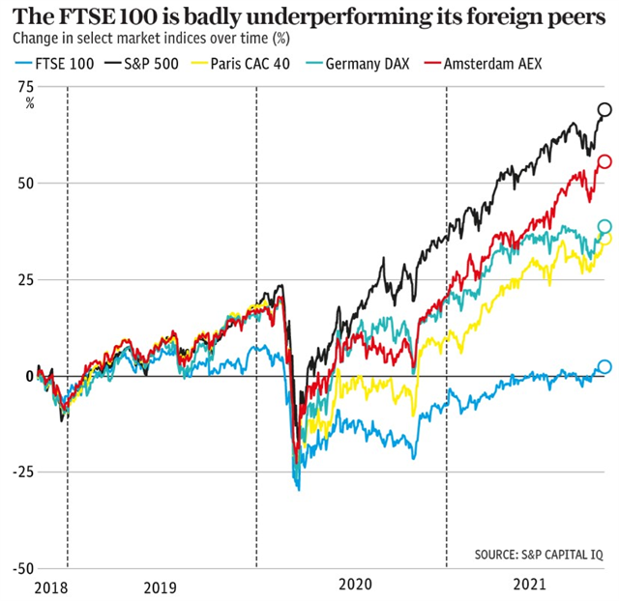
As you can see from the graph the UK listed companies have trailed 50% behind their US peers, and 24% behind European equities. The main cause of this is that British stocks tumbled more heavily than other markets over Covid and were particularly behind other markets since the Brexit vote in 2016.
The graph clearly demonstrates the need to spread investment plans over all the markets in order to spread risk and not keeping all your eggs in one basket.
On a brighter note, as a result of the current position of the UK markets, UK stocks are now considered cheap and very attractive for the future. Watch this space.
Keep safe. It’s still out there
Ray

