Planning towards a flexible retirement
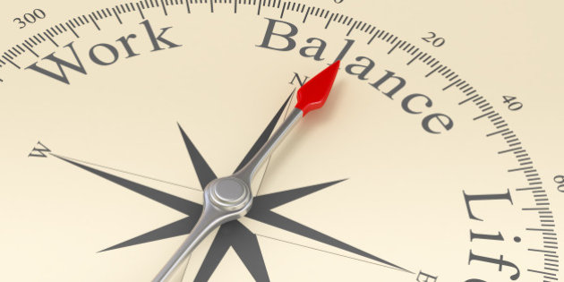
According to the latest Office for National Statistics figures, for December 2017 to February 2018, just under 1.2 million people over the age of 65 were in work - or 10.2% of the entire workforce.
As the graph shows a steadily increasing percentage of people remain working over the age of 65. It was about 4.5% in 2001 to currently over 10%.
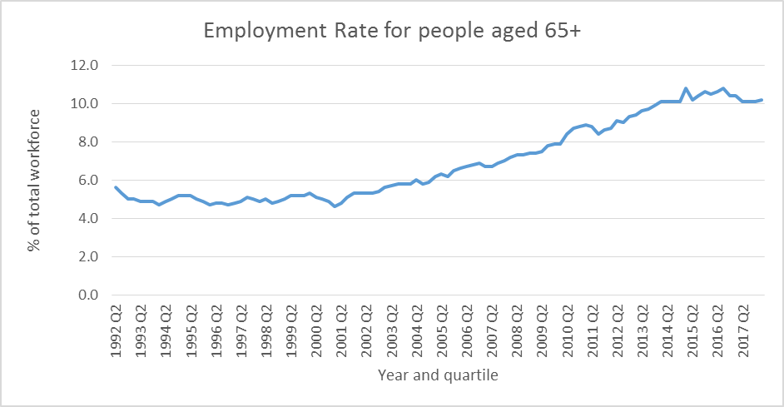
Source: Office of National Statistics
Here are 6 ideas that can help you in planning your flexible retirement:
- LOOK TO REDUCE YOUR HOURS WITHIN YOUR CURRENT EMPLOYMENT
Talk to your employer about reducing your hours rather than taking the plunge and quitting your job completely when it comes to retirement time. Your fall in income will not be as drastic as quitting completely.
- LOOK TO START WORKING FREELANCE
After leaving employment you could always work as a freelance consultant maybe on a full or part time basis.
- DELAY YOUR STATE PENSION
If you are able to remain in work, either as a part-time employee or as a freelance consultant, when you become eligible for the State Pension, you may not need it immediately.
You can delay these payments if you think that you do not need them at this moment in time. For every nine weeks you delay, the government will increase your payments by 1%. This works out to just under 5.8% a year.
- YOU ARE ALLOWED TO TAKE INCOME FROM A PENSION AND PAY INTO ANOTHER ONE AT THE SAME TIME
You can use a drawdown pension to start taking a flexible income from your pension while you work. This could be particularly useful if you decide to reduce your hours to work part time or as a part time consultant and need to top up your income.
A great advantage of drawdown is that you can take up to 25% of your total pension pot as a tax-free lump sum. Even though the government have a Money Purchase Annual Allowance (MPAA), which only allows you to contribute up to £4,000 a year to a pension; by taking the tax-free lump sum the amount you can pay into your pension will not be affected.
You must remember that tax rules can change and the value of any benefits depends on your personal circumstances.

- IT IS BETTER TO HAVE YOUR PENSION IN ONE POT
Bringing together all your pensions into one pot makes your finances more manageable. It provides the opportunity to review your pension investments and to select new ones more suited to your new risk profile. We often find that a new pension has lower charges and much more flexibility.
- TAKING PENSION INCOME FROM YOUR ISAs
Taking your pension income from your ISAs gives you an income, which is completely tax-free. This means that your pension can be left to your children tax-free.

